Coding homework Report

Naik Hiong Chiang

PROBLEM 1:

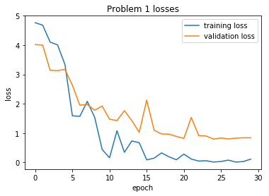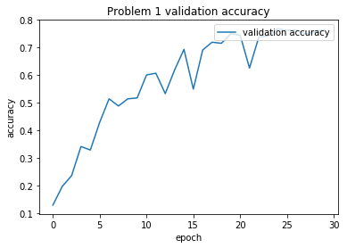

Test set: Average loss: 1.0325, Accuracy: 962/1278 (75%)

average validation accuracy: 0.5858633281168492

medium validation accuracy: 0.6216744913928013

max validation accuracy: 0.7668231611893583

--------------------------------------------------

PROBLEM 2:

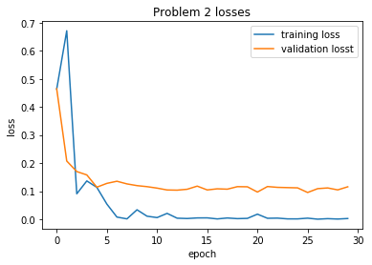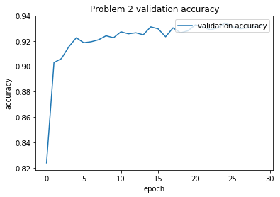

Test set: Average loss: 0.1348, Accuracy: 1232/1278 (96%)

average validation accuracy: 0.9220657276995304

medium validation accuracy: 0.9268388106416275

max validation accuracy: 0.9342723004694836

--------------------------------------------------

PROBLEM 3:

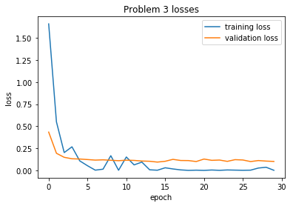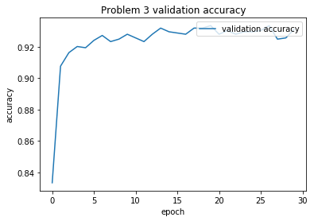

Test set: Average loss: 0.1141, Accuracy: 1235/1278 (97%)

average validation accuracy: 0.9236045905059989

medium validation accuracy: 0.9280125195618153   
max validation accuracy: 0.9334898278560251

Observer differences between the validation and the test accuracy of these models:

The accuracy of the test set performs greater when we are comparing against the medium and the average accuracy as we are using the best model saved during the validation state. However, when compared to the max validation accuracy, it only differs a bit.